Imprinting Order Form
INSTRUCTIONS AND PRICING:  - PRINT clearly and complete the entire Order Form.  - Use a separate Order Form for EACH album. |  |  | Use this book chart to find the location you want for each imprint line. Circle the appropriate letter in the section below.  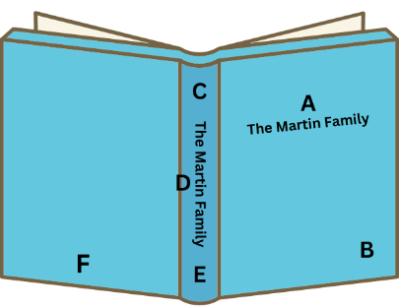
  Name:
  Date:
  Phone #:
  Album Size:
  Album Color:
  $10 | Wording per line (approx. 33 spaces in 24 pt)  (approx. 22 spaces in 36 pt)
  $5 | Repeat same line onto spine or onto additional albums
  $5 | Volume or date
  $5 | Graphic Die or “Made with love by Mom/Grandma”
Print on the lines below, the EXACT text you want imprinted. Then write your font style choice, font size, and circle the imprint location letter for each line. | Font Style Name | Font Size # | Imprint Location on Album
Line 1 |  |  | A B C D E F
Line 2 |  |  | A B C D E F
Line 3 |  |  | A B C D E F
Line 4 |  |  | A B C D E F
Line 5 |  |  | A B C D E F
Please enter your choice of FOIL COLOR here: _____________________________________________

View order folder for font styles and size options, foil colors and graphics available. | Please see me with any questions.

